Week 3:
Step 1: I made a network using GNS3 with four hosts and a switch and I set its IP address manually. Example: Host 2 was assigned with an IP address of 192.168.0.2 with a netmask of 255.255.255.0 with a gateway of 192.168.0.1.

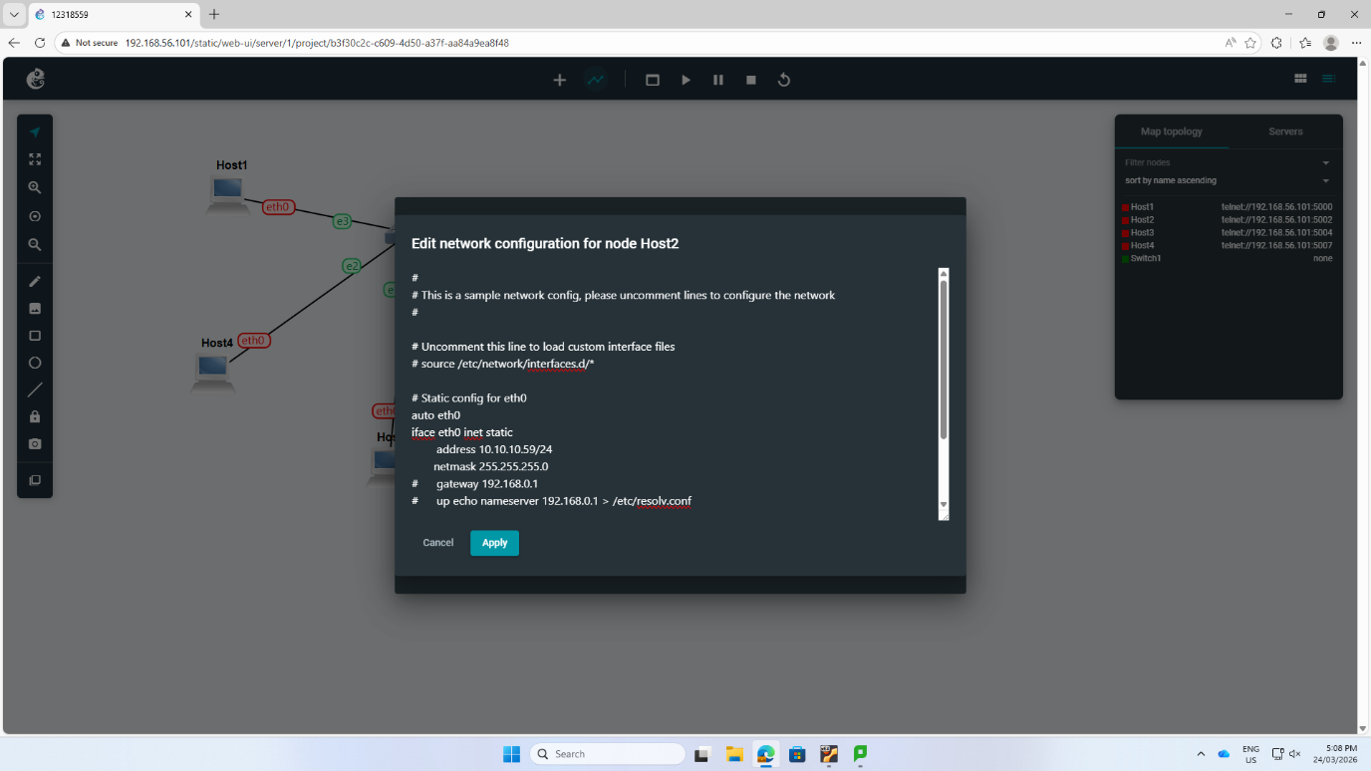
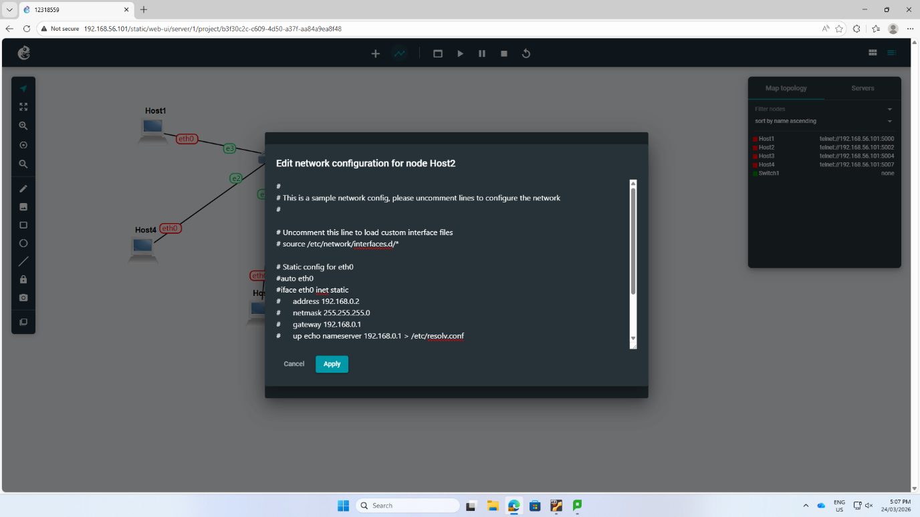

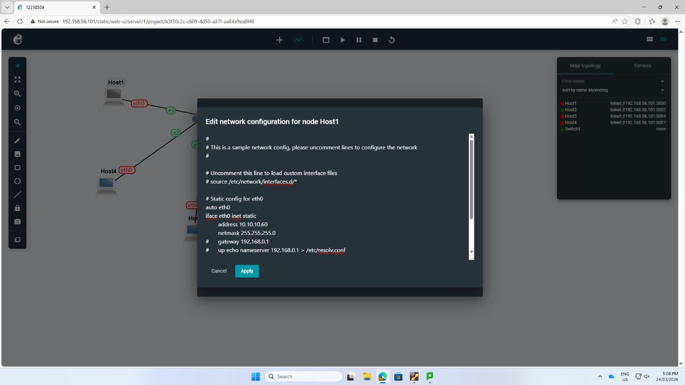

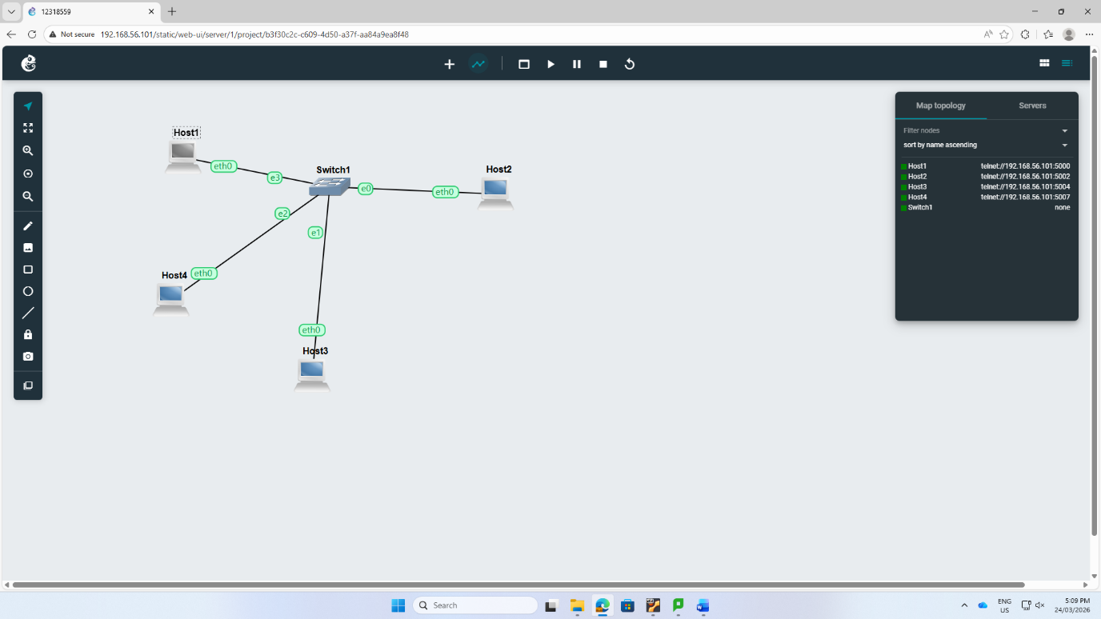

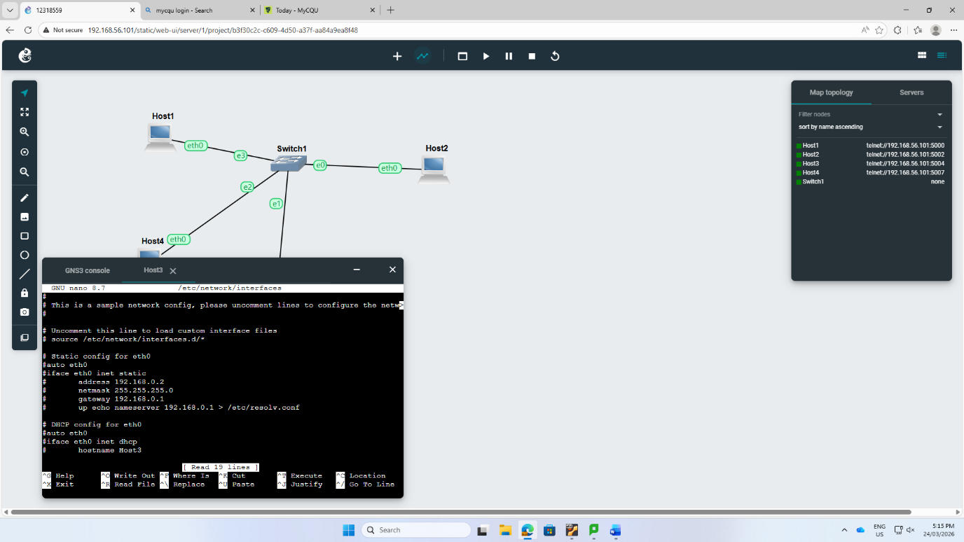
Step 2: I used ip add show command to see if IP address is correctly implemented to eth0 interface.
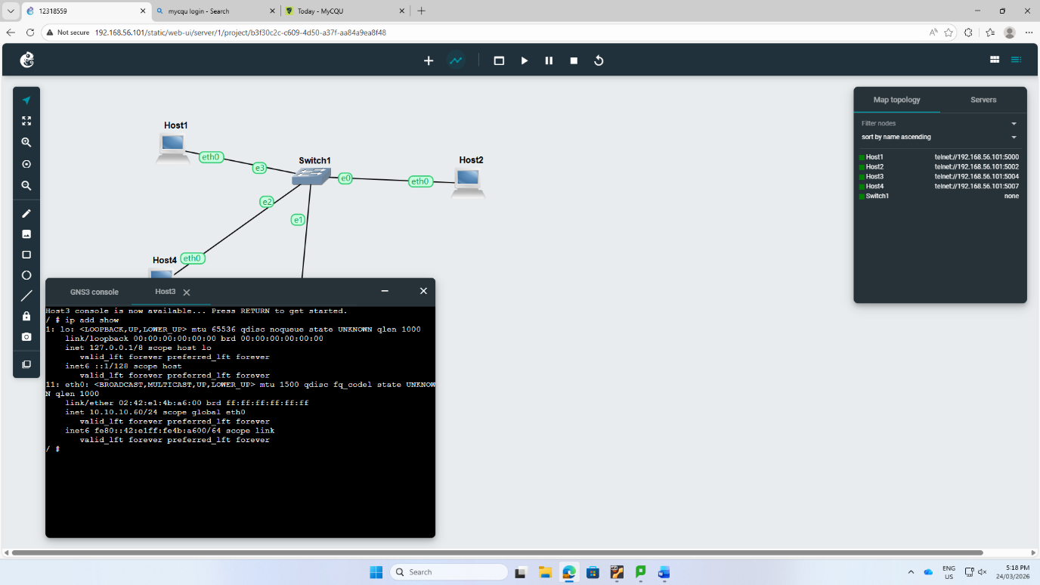

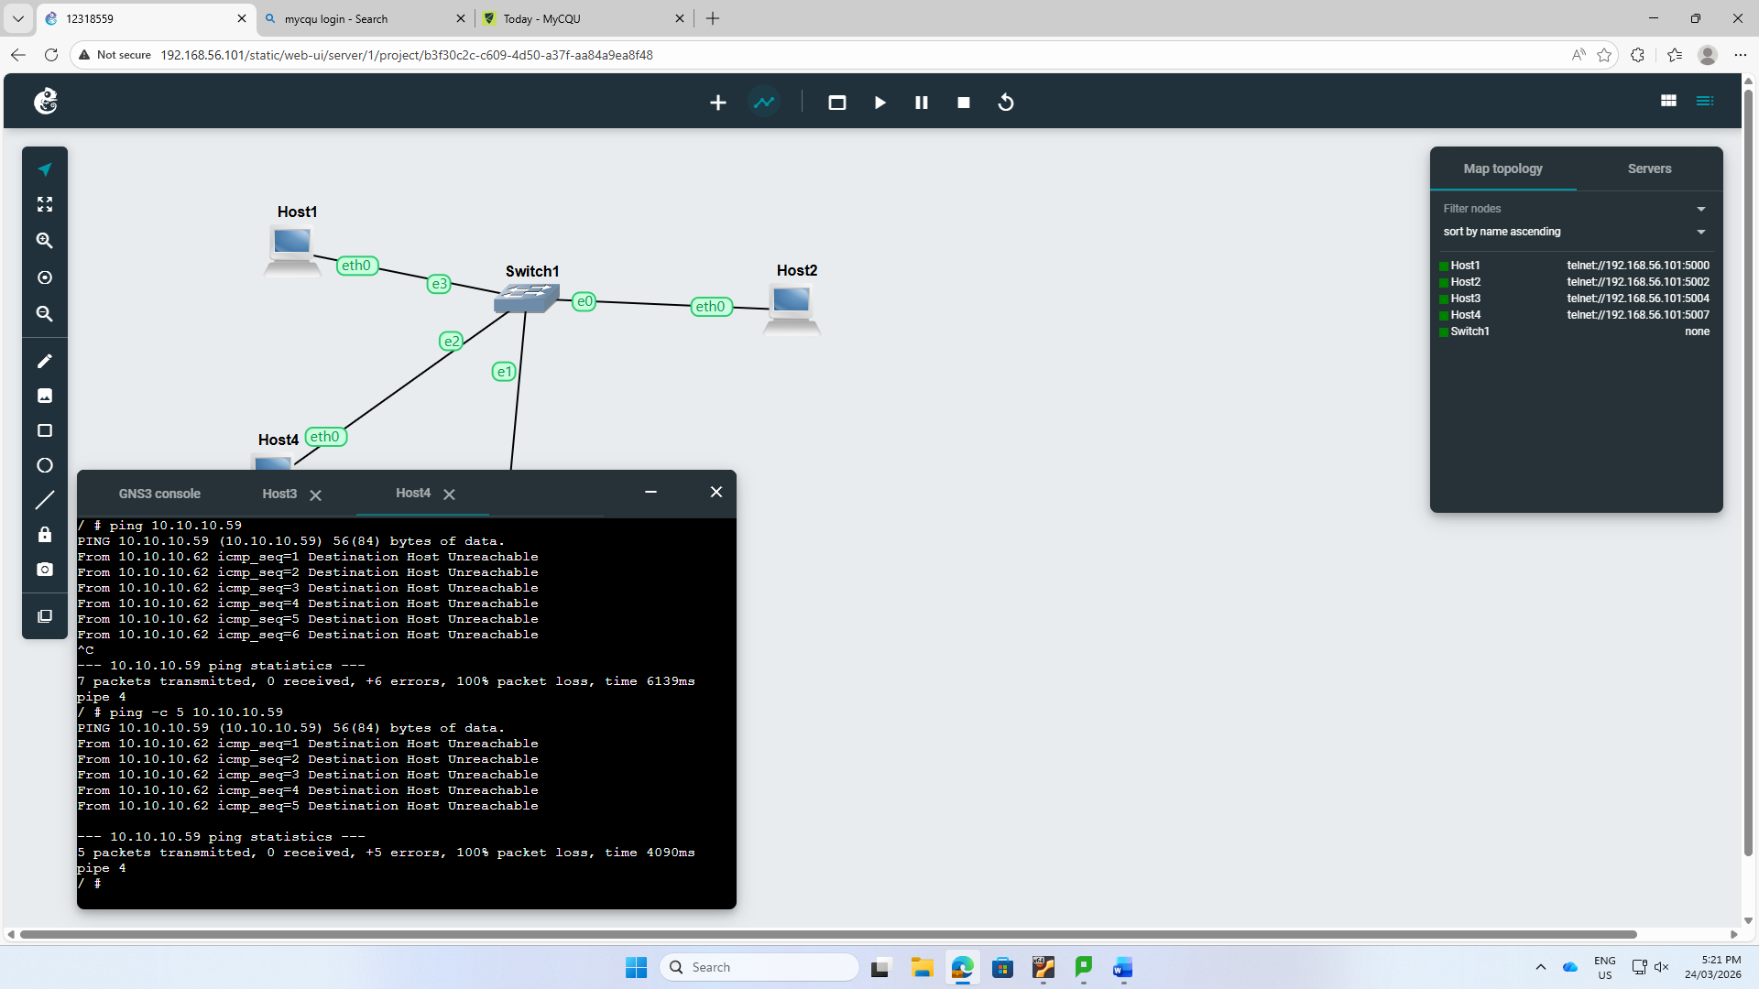
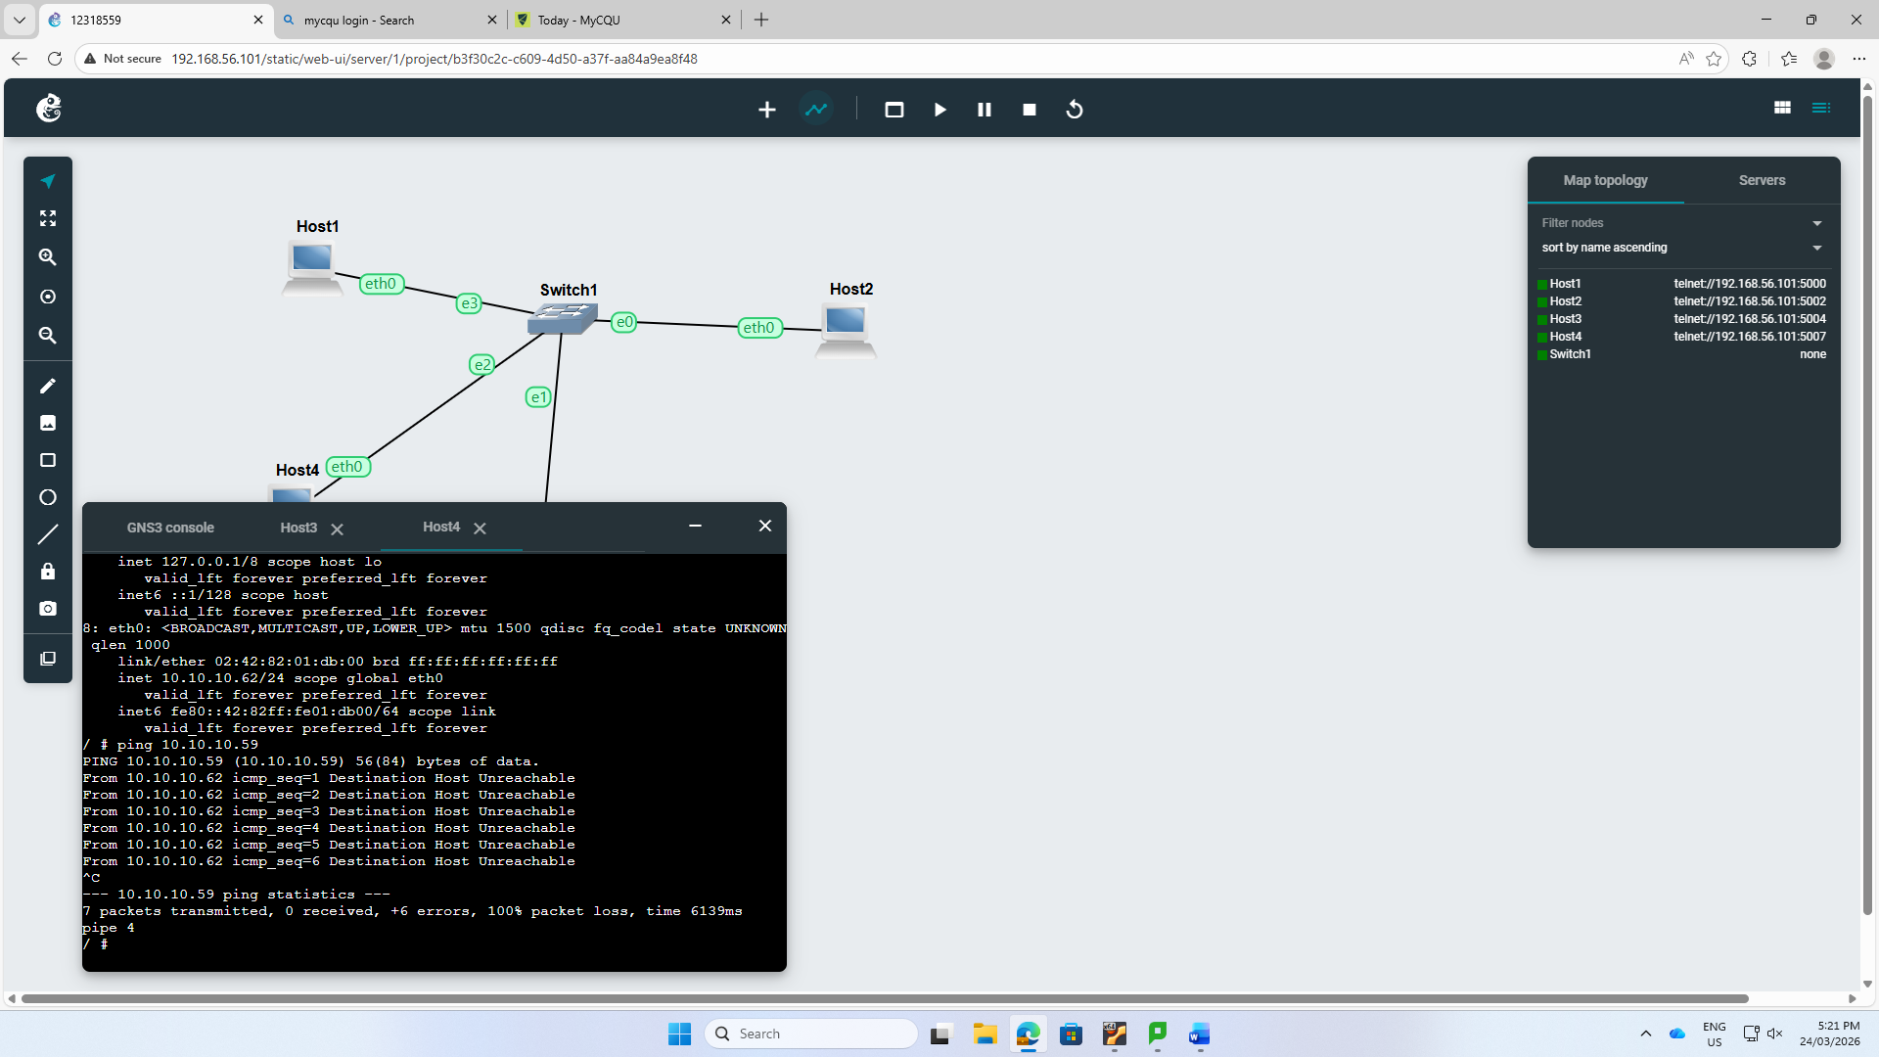
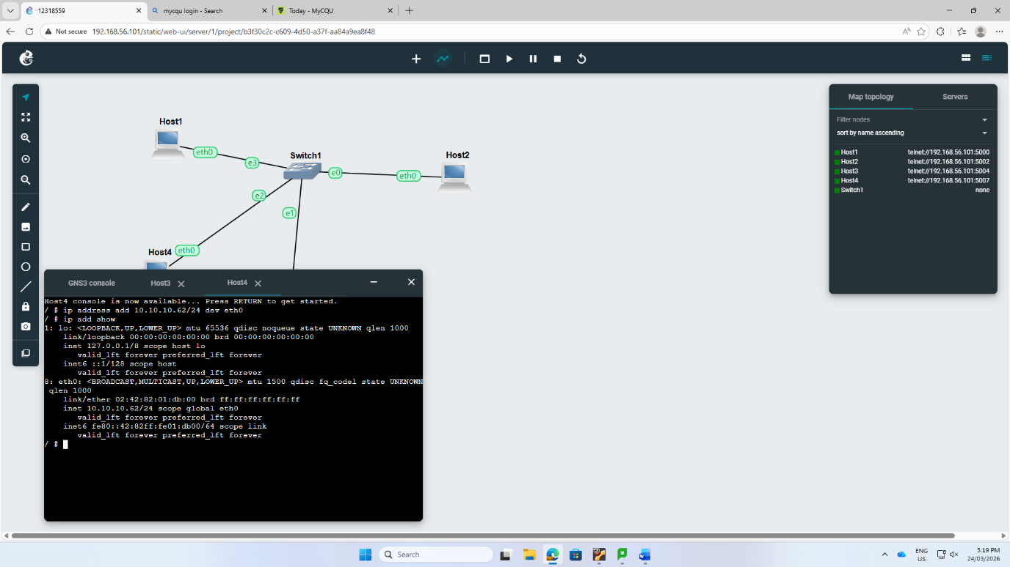
Step 3: I tried to ping hosts to test connectivity between them but
then I faced an error that said “Destination Host Unreachable”. That was meant that communication between hosts is not guaranteed.



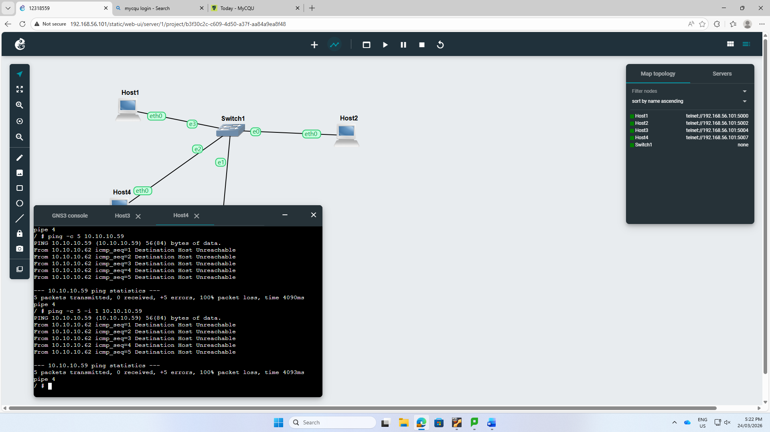



Step 4: So, to fix the error, host1 was configured as a server by putting it on a specific port(33333) using the command (nc -1 -p 33333).

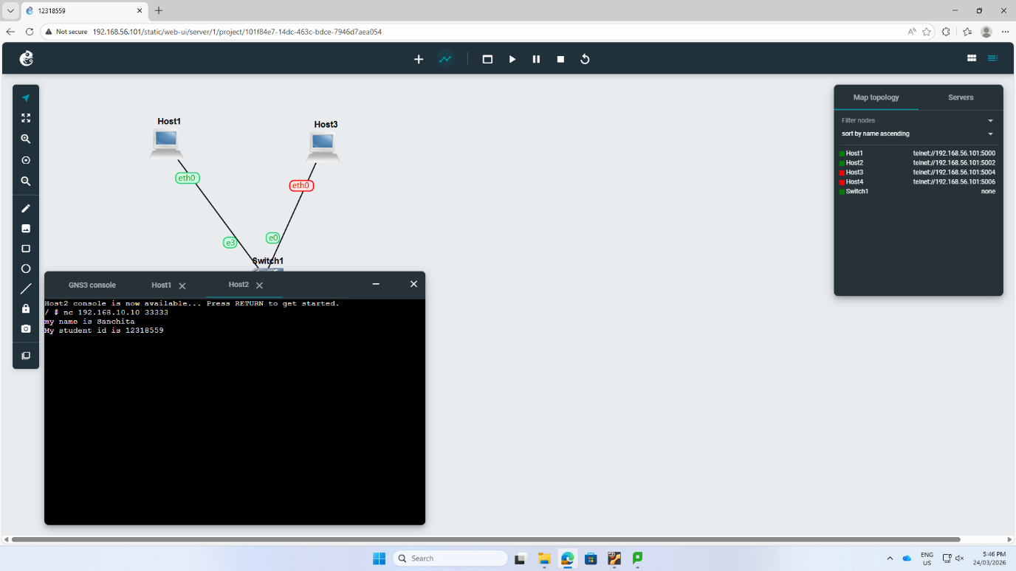

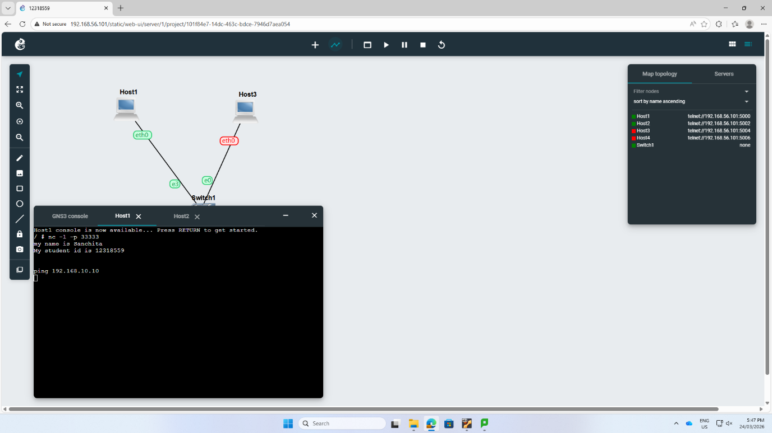
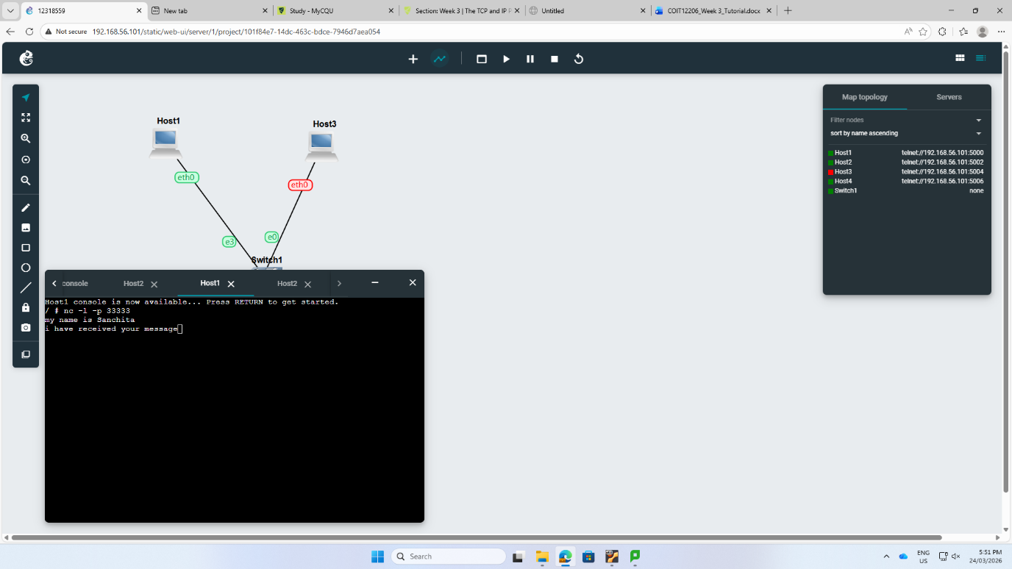
Step 5: Host 2 was used as a client to link to the sercer’s IP address and port.

Step 6: Personal identification data is successfully transferred from client to the server. It proves that the transport layer is working properly.

Step 7: FileZilla was used to build an SFTP connection to the GNS3 server.



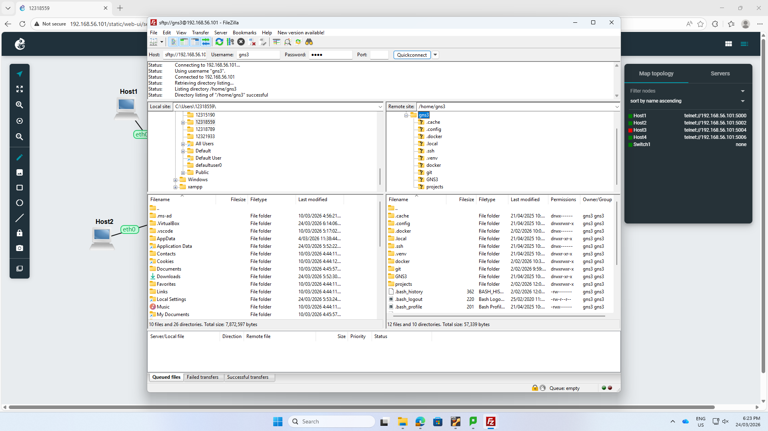

Reflection: In week 3, I learnt from fundamental host configuration to using advanced dynamic routing, successfully building static IP addressing, VLAN segmentation. There were challenges and errors that said destination was unreachable. But I somehow managed to fix that error. That error also taught me that only physical connections are not enough without logical routing and gateway sub-interfaces. I used ovs-vsctl show and show ip ospf neighbor to gain practical skills. Altogether, these tutorial taught me the strong knowledge for layer 2 and 3 networking.

